No.: ………………… ..………………, ………………..

*(to fill by customs agency)*   *(place,date)*

**Authorization**

to act as a representative office: direct / indirect**\***

Pursuant to the EU CUSTOMS CODE in the Regulation of the European Parliament and of the Council (EU) No 952/2013 of 09.10.2013, I authorise the customs agency **AC EURO-POL sp. z o.o. with its registered office in** **Brzeźno,ul. Chełmska 11, NIP: 5252800607 REGON: 384329260 KRS: 0000803098** to undertake on behalf of:

…………………………………………………………………………………………………………

…………………………………………………………………………………………………………

*(name and address of company)*

NIP: ……………………………….. EORI: ……………………………………..

TEL.: ……………………………… E-MAIL: ………………………………….

the following activities and formalities related to trade in goods with foreign countries:

1) all activities in the field of customs and tax;

2) representation before all customs authorities;

3) submission of all kinds of applications and appeals to the customs or tax authorities;

4) total handling related to customs clearance;

5) handling simplified procedures in the field of customs declarations;

6) registration, updating and representation in the PUESC system;

7) submission and receipt of certificates of origin and EUR 1

8) submission of security

All customs agents working in **AC EURO-POL Sp. z o.o.** are entitled to perform the above activities, regardless of staff turnover.

This authorization is:

1) permanent

2) disposable

3) timely until …………………

Confirmation of acceptance of the authorization

…………………………………………….. …………………………………………

*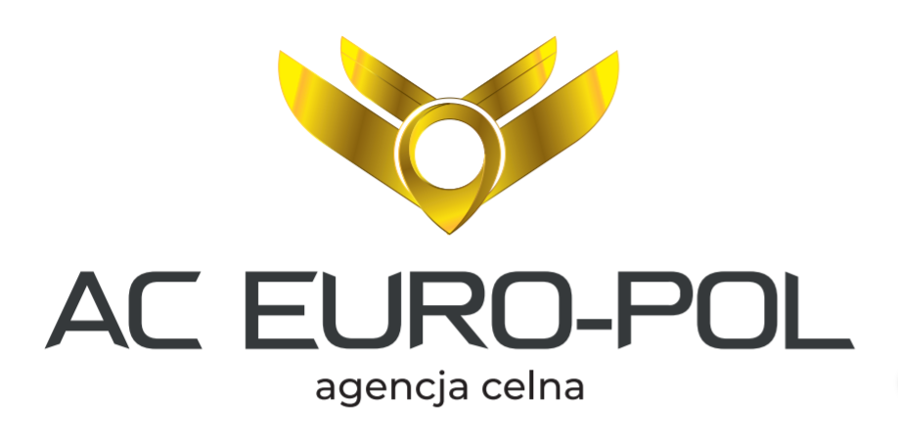(date, sygnature of customs agency)*  ***(date, name, surname and signature of an***

***authorized person, company’s stamp)***